A frequent question that comes up is the one that concerns how best to control the light to reduce the chances of over or under exposure. It’s such a regular topic I thought it might be helpful if I wrote a short article on the arcane mysteries of the photographic equivalent of the Bermuda Triangle - the Exposure Triangle...
Us photographers work with light. I like to think of us as lightsmiths similar to blacksmiths, silversmiths and any other smith other than John Smith you can think of. Light is our raw material and from it we need to forge images that are not only pleasing to the eye but are of a high enough standard to pass muster either by ourselves and/or our peers. But light is a fickle thing. Around us in spades one moment and literally vanishing before our eyes the next - I’m from the Lake District so I know a thing or two about the changeability of light. So. If we are to work with this constantly changing medium, and don’t intend spending the rest of our photographic lives in a studio where you more or less control it to your hearts content, then we need an understanding of how we can use light to our advantage. For that we need to firmly grasp the concepts that underpin the Exposure Triangle.
Warning* - You may have to use Manual on your camera or the very least shutter or aperture priority. If you’re not sure how to do that then consider looking at the pdf that usually comes with your camera or an online resource for more information.
*Takes a deep breath* Here we go:
Oddly enough there are three core components of the Exposure Triangle:
Depth of Field (or DOF as I’ll call it from now on)
Shutter speed
ISO

We’ll deal with each one below:

Depth of Field - DOF is essentially the distance between the nearest and furthest objects that appears reasonably sharp. I don’t want to turn this article into a treatise on DOF as it’s a subject in its own right but if you look at the image below it will hopefully give you some idea of DOF and how it can influence an image. Here, for me at least, the most important aspect of the subject is its eyes, beak and the seed. Having the chest feathers sharp was also important but certainly less so than the all important face. The nearest object is the seed and the furthest acceptable point of sharpness is probably the feet. Clearly the lower half of the bullfinches body is starting to lose focus and the tail has become a blur. That is the effect of DOF. The lower the number - f1.8, f2, f4 etc the harder it will be to keep everything in focus but the more light you will have available to you.
Start to ramp up the DOF and you’ll see a halving of the light for every stop you increase DOF by but more of the subject will appear sharp. Factors that influence DOF include the type of lens you use - wider angle lenses need less DOF to keep everything sharp and big prime lenses are very unforgiving at the lower numbers giving you only wafer thin DOF. The size of your subject in relation to the background is another factor. Macro work especially needs more DOF if you want to keep the subject sharp from front to back - but that’s also another article!
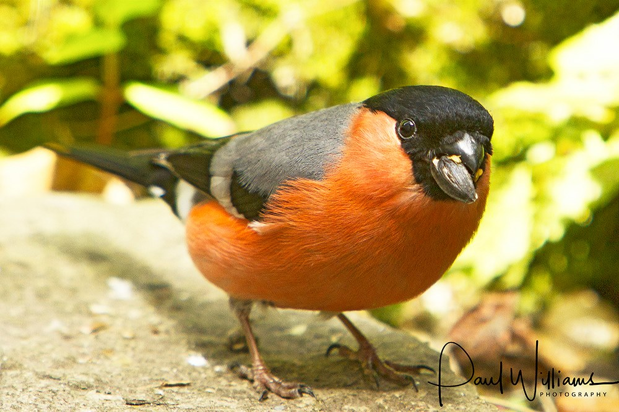Good DOF is important but not as important as a nice seed..
Shutter speed - think of your shutter as a pair of curtains (bear with me on this). The longer you have the curtains open the more light you let in. Flick them open and shut in the blink of an eye and you’ll get a brief period of light followed by darkness once more. That’s how the shutter in your camera works. It goes without saying that certain subjects need faster shutter speeds than others; landscapes generally won’t need anywhere near the speed that a peregrine falcon in flight might require for instance. With that in mind I strongly suggest you get to know the approximate shutter speed you need for the subject you might be photographing.
Birds in flight (BIF) are notoriously tricky to photograph and capture effectively as you have the twin pressures of a small, often rapidly moving object against a sky that usually has an exposure value way above that of the bird. Only experience and lots of trial and error will get you to the point of feeling confident that the shutter speed you’ve chosen is quick enough to freeze movement for any given species or situation. Just like DOF shutter speeds work by halving or doubling the light available. The longer the shutter speed (or curtains being open) the more light you let in and vice-versa. Slower shutter speeds will look like 1/15th or 1/8th whereas higher speeds will be more like 1/1000th.
I’ve already said a slower shutter speed will give you more light but this will come at the expense of either camera shake or blur in the subject if you aren’t careful. A tripod is essential for really low speeds and if your lens come with IS (image stabilization) then consider using it as it will help reduce camera shake to a degree. Below is an image of a puffin in flight bringing in a beak full of sand eels. To capture this as sharp as I wanted it I reduced the DOF to f5.6 as the bird is relatively small and needed less DOF. I then took a couple of test shots at different speeds until I was happy that 1/2000th was cutting it and moved the ISO to the point where f5.6 and 1/2000th was creating a well exposed image - which takes us neatly to the final part of the triangle:

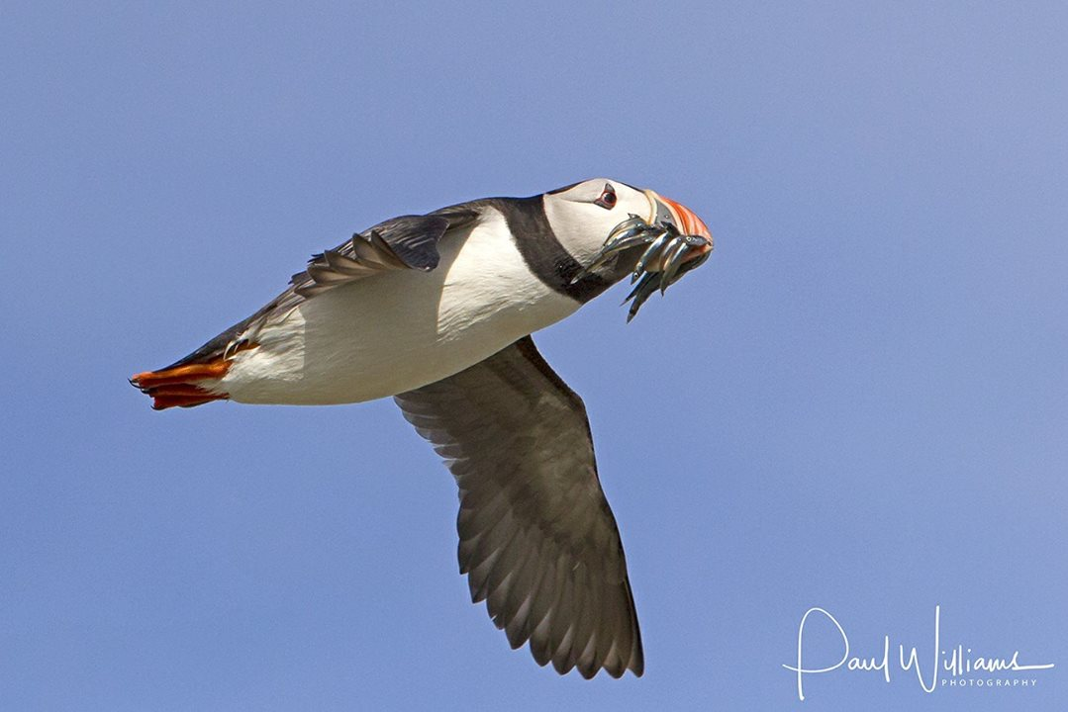
Sharp or in the bin it goes...
ISO - Back in the olden days (a whole ten or so years ago) there was a thing called film. You paid crazy prices to stick it into your camera and it gave you around 36 chances of capturing a good image - but you never got to know if you had as it had to be rewound into its little case and sent off by post or physically taken into a nice man or woman who developed it. Several interminable days (hours if you took it in and upgraded to express) later your prints arrived and you either wept with joy or anguish depending on the results. Film at the time was graded according to its speed - the faster the film the easier it was to achieve a satisfactory balance of the two subjects I’ve covered above. The paradox is of course there’s no such thing as a free photographic lunch and with increased film speed came grain - or noise as we now know it in the halcyon days of the digital revolution.
Noise, generally speaking, is to be avoided, or at the very least reduced as it’s considered by many to be detrimental to the overall ambience of an image. As with all such understandings there are caveats and I know of many very good photographers out there actively using noise to create images full of atmosphere and beauty - but for the purposes of this article I’m trying to get you to reduce noise within the boundaries of the triangle to help you achieve the images you rightly hanker after.
Most modern cameras deal with noise fairly well up to a certain level beyond which you’ll see an incremental (once more we’re dealing with halves and doubles of light here) increase in noise. Where that level is will depend on the quality of your sensor, the pricing point of your camera and the light conditions/subject matter you’re photographing. Get to know the point at which you’re not prepared to accept the level of noise and work within those parameters if possible. There will always be a moment when you have to make a decision to accept a level of noise you wouldn’t normally entertain because what’s going on in front of you is so amazing or unique you’re prepared to pay the ferryman. If you have access to photography software such as Photoshop or Lightroom then spend some time on digging out articles or tutorials on reducing noise or at the very least getting some of the colour that comes with noise out of your image. I’ve linked in a good article on that very subject at the bottom of this note.
I’ve added an image I took in near dark the other morning to show how noise can affect the overall image. Although not easily discernible at this size I know I couldn’t take this image much further than the size you see here without the noise becoming very apparent - as it is the tones are too muted and the overall detail is lacking. Consider the final use of the image you want to take - is it going to be a jpg on the web or an A2 poster. You can get away with more noise in a smaller image for the web than you will with a larger poster-sized print going on someone’s wall.
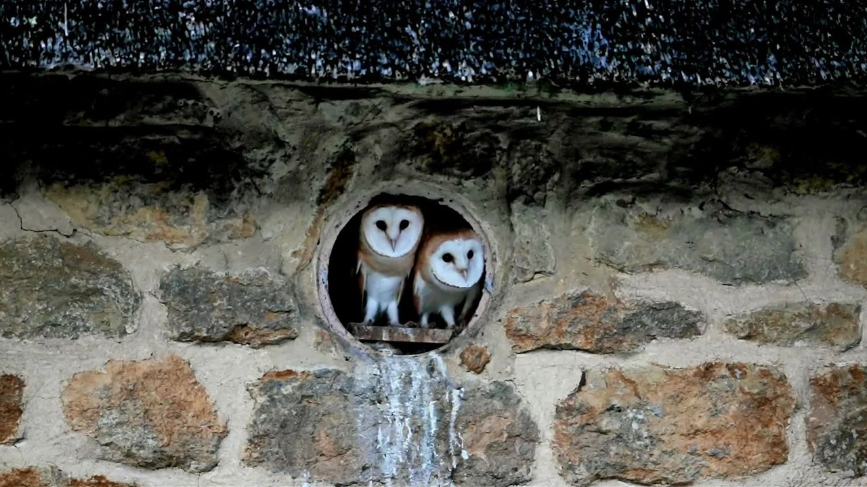
Owlets not roaming in the gloaming

You now know a little more about DOF, shutter speed and ISO - the three cornerstones of the Exposure Triangle. Like any triangle there are certain rules to adhere to if the triangle is going to work for you rather than against you. The tensions between each side of the triangle have to be equalised if you want to create well-exposed, sharp images as free from noise as you can get. If shutter speed is your priority then set your values and be prepared to adjust the DOF and/or the ISO. If shutter speed and DOF are important (and they usually are) then you have to weigh up the lowest shutter speed you can get away with along with the minimum DOF to achieve a good image. If the only wriggle room you have left is ISO then get to know how high you can go before your shot will start to look like the surface of the moon.
Weather, the time of year and even the time of day play a big part in determining how much light you have available to you to craft your image. Often your subject will decide the time of day for you (think owls here) so again you have to think on your feet and be flexible. I can’t emphasise how important it is to really get to know your camera and its limitations re noise, shutter speed and the DOF your lens will allow you. If you have a set budget (who doesn’t) consider spending a bit more on the lens than on the body as the camera is only as good as the glass in front of it. For those of you with point and shoot or bridge camera’s the article is perfectly suited to you as well. The rules still apply and the results will come if you’re prepared to move out of your comfort zone and embrace this way of working.
That’s just a brief foray into the Exposure Triangle but I hope it’s been of some help to you in understanding the interplay between DOF, shutter speed and ISO. There are literally hundreds of forums, tutorials and articles on the web so explore them, gain more knowledge and get out there and put some hours in until your understanding of your equipment and your skill level gets you to the point where there is literally no such thing as bad weather or bad light...

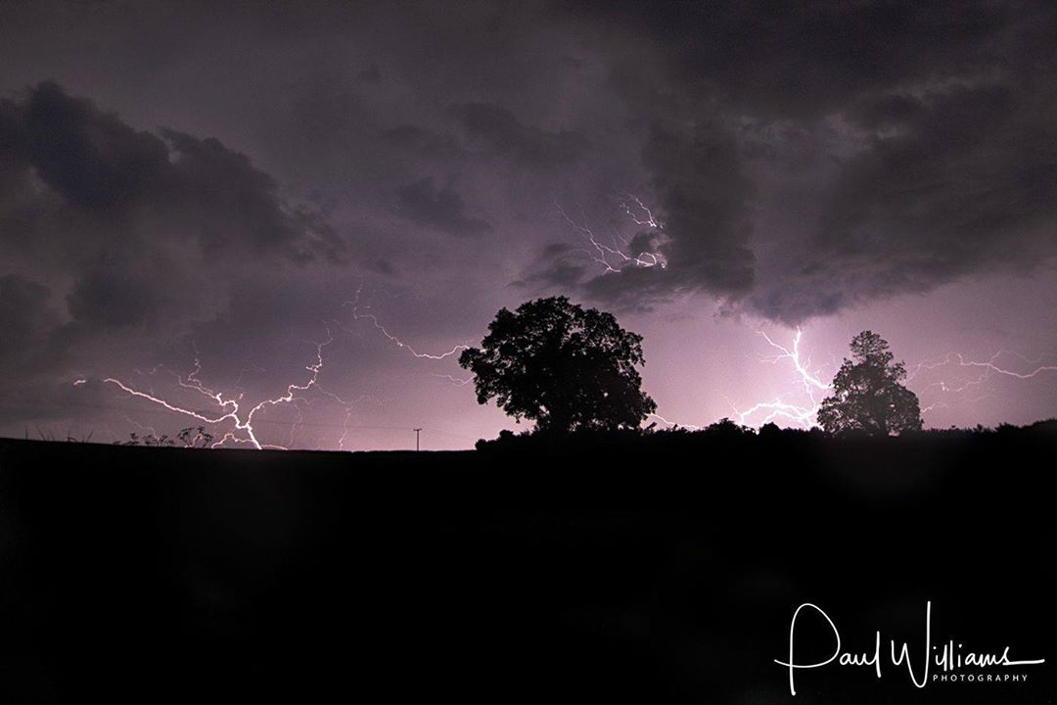
There's no such thing as poor weather or bad light...

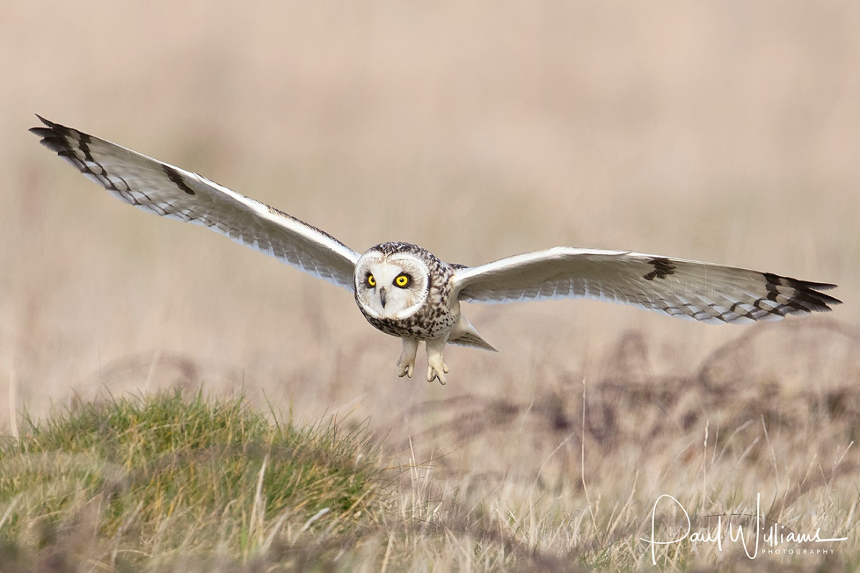
Short eared owl in low light

An excellent article on reducing noise in camera raw by the f64 academy:
http://f64academy.com/reduce-noise-

